ICOM-US Webinar Series
Reference Guide
Part Six:
What Now?
Recording of the webinar will be accessible to ICOM-US members in the members only section of the Icomus.org website. View by logging into your profile to visit the video library, https://www.icomus.org.

Today’s presentation background information: Part Six: What Now?
https://www.icomus.org/webinar-series--part-six

Previous Webinar Series Reference Materials: https://www.icomus.org/upcoming-events

Introduction: https://www.icomus.org/webinar-series--intro

Part One: Safe Places or Social Spaces? https://www.icomus.org/webinar-series--part-one

Part Two: The Function of Collecting: https://www.icomus.org/webinar-series--part-two

Part Three: The Whiteness of Museums: https://www.icomus.org/webinar-series--part-three

Part Four: Museums as Influencers: https://www.icomus.org/webinar-series--part-four

Part Five: Crisis: Environmentalism, Sustainability, and Museums: https://www.icomus.org/webinar-series--part-five

____________________________________________________________________________________

May 18-23, 2021. Don't miss your chance to watch the full series recordings!
In Celebration of International Museum Day, May 18, 2021, free access will be granted for one week only to the public to view the complete ICOM-US "What is a Museum? An Exploration in Six Parts" webinar series recordings.
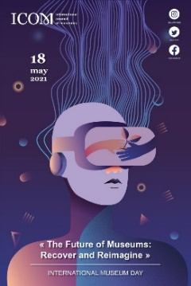
Please note: All ICOM members will have lifetime access to the recordings following the international museum day special. Non-members will be able to purchase the series or receive free access by submitting an ICOM-US membership application. The above password information will change once the international museum day special ends.

SAVE THE DATE: MAY 18, 2021
MAKE SURE TO CELEBRATE INTERNATIONAL MUSEUM DAY!
International Museum Day 2021 Theme:
The Future of Museums- Recover and Reimagine
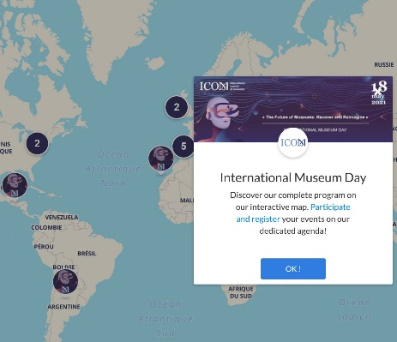
The International Museum Day 2021 interactive map is online!
New! This year, a tag allows you to select on-line / on-site events. Register your activities for #IMD2021 here!
Find more information on the IMD 2021 website here: http://imd.icom.museum/
______________________________________________________________________________
Take part in the new definition of the museum! Follow along with ICOM-US as we go through the methodology on our website here: https://www.icomus.org/icom-define-methodology
Want to know how to get more involved with ICOM? Join and international committee today!
______________________________________________________________________________
ICOM-US Sessions Held at AAM Virtual Conference June 7-9, 2021
More information coming soon: https://www.icomus.org/annual-meeting
- Tuesday, June 8, 2021 from 2:00-3:00pm CT/3:00-4:00pm ET: The Great Debate—What Is a Museum? A Worldwide Debate of a New Definition.

- Wednesday, June 9, 2021 from 9:00-10:00am CT/10:00am-11:00am ET: Impact: International Hot Topics in Museums.

--> #AAMVirtual Registration is NOW OPEN!

